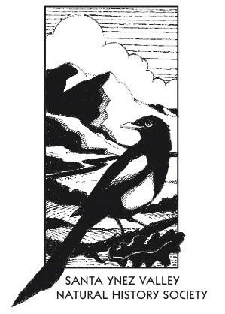
Yes, I would like to renew membership or become a member of the Santa Ynez Valley Natural History Society!

Please record my membership at the following level of support:

_______ $ 10 Annual Student or Limited Income
_______ $ 35 Annual Individual
_______ $ 50 Annual Family
_______ $100 Annual Supporter
_______ $150 Annual Sponsor
_______ $250 Annual Patron
_______ $500 Champion
_______ Other

Name(s) ____________________________________________________________________________

Mailing Address ______________________________________________________________________

City ________________________________________________________________________________

State _______________________________________________________________________________

Zip Code ____________________________________________________________________________

Email __________________________________________________________________________ ____

Phone ______________________________________________________________________________

None of the information above will be shared with any other organization or group.

Please send this completed form with your check payable to:
Santa Ynez Valley Natural History Society
PO Box 794
Los Olivos, CA 93441

Contact us:
Santa Ynez Valley Natural History Society
PO Box 794
Los Olivos, CA 93441
805-693-5683
syvnhs@syvnature.org
www.syvnature.org

